**WEEK 3 – MODULE 5**

**Exercise 1: Configuring a Basic Spring Application:**

Project: LibraryManagement

**pom.xml file:**

<project xmlns="http://maven.apache.org/POM/4.0.0"

xmlns:xsi="http://www.w3.org/2001/XMLSchema-instance"

xsi:schemaLocation="http://maven.apache.org/POM/4.0.0 https://maven.apache.org/xsd/maven-4.0.0.xsd">

<modelVersion>4.0.0</modelVersion>

<groupId>com.studytonight</groupId>

<artifactId>springproject</artifactId>

<version>0.0.1-SNAPSHOT</version>

<packaging>jar</packaging>

<dependencies>

<dependency>

<groupId>org.springframework</groupId>

<artifactId>spring-core</artifactId>

<version>${spring.version}</version>

</dependency>

<dependency>

<groupId>org.springframework</groupId>

<artifactId>spring-context</artifactId>

<version>${spring.version}</version>

</dependency>

</dependencies>

<properties>

<spring.version>5.2.8.RELEASE</spring.version>

</properties>

<build>

<sourceDirectory>src</sourceDirectory>

<plugins>

<plugin>

<artifactId>maven-compiler-plugin</artifactId>

<version>3.8.1</version>

<configuration>

<source>1.8</source>

<target>1.8</target>

</configuration>

</plugin>

</plugins>

</build>

</project>

**BookRepository.java:**

package com.library.repository;

public class BookRepository {

public void save() {

System.out.println("Book saved to database.");

}

}

**BookService.java:**

package com.library.service;

import com.library.repository.BookRepository;

public class BookService {

private BookRepository bookRepository;

public void setBookRepository(BookRepository bookRepository) {

this.bookRepository = bookRepository;

}

public void addBook() {

System.out.println("Book added");

bookRepository.save();

}

}

**Main.java:**

import com.library.service.BookService;

import org.springframework.context.ApplicationContext;

import org.springframework.context.support.ClassPathXmlApplicationContext;

public class Main {

public static void main(String[] args) {

ApplicationContext context = new ClassPathXmlApplicationContext("applicationContext.xml");

BookService service = (BookService) context.getBean("bookService");

service.addBook();

}

}

**OUTPUT:**

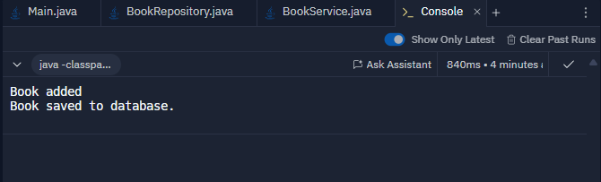

**Exercise 2: Implementing Dependency Injection:**

**BookRepository.java:**

package com.library.repository;

public class BookRepository {

public void save() {

System.out.println("Book saved to database.");

}

}

**BookService.java**

package com.library.service;

import com.library.repository.BookRepository;

public class BookService {

private BookRepository bookRepository;

public void setBookRepository(BookRepository bookRepository) {

this.bookRepository = bookRepository;

}

public void addBook() {

System.out.println("Adding book...");

bookRepository.save();

}

}

**applicationContext.xml**

<?xml version="1.0" encoding="UTF-8"?>

<beans xmlns="http://www.springframework.org/schema/beans"

xmlns:xsi="http://www.w3.org/2001/XMLSchema-instance"

xsi:schemaLocation="http://www.springframework.org/schema/beans

http://www.springframework.org/schema/beans/spring-beans.xsd">

<bean id="bookRepository" class="com.library.repository.BookRepository" />

<bean id="bookService" class="com.library.service.BookService">

<property name="bookRepository" ref="bookRepository" />

</bean>

</beans>

**Main.java**

import com.library.service.BookService;

import org.springframework.context.ApplicationContext;

import org.springframework.context.support.ClassPathXmlApplicationContext;

public class Main {

public static void main(String[] args) {

ApplicationContext context = new ClassPathXmlApplicationContext("applicationContext.xml");

BookService service = (BookService) context.getBean("bookService");

service.addBook();

} }

**Output:**

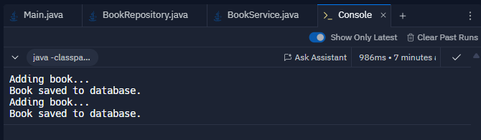

**Exercise 4: Creating and Configuring a Maven Project:**

**pom.xml File:**

<project xmlns="http://maven.apache.org/POM/4.0.0"

xmlns:xsi="http://www.w3.org/2001/XMLSchema-instance"

xsi:schemaLocation="http://maven.apache.org/POM/4.0.0

http://maven.apache.org/xsd/maven-4.0.0.xsd">

<modelVersion>4.0.0</modelVersion>

<groupId>com.library</groupId>

<artifactId>LibraryManagement</artifactId>

<version>1.0-SNAPSHOT</version>

<!--Spring Dependencies -->

<dependencies>

<!-- Spring Core and Context -->

<dependency>

<groupId>org.springframework</groupId>

<artifactId>spring-context</artifactId>

<version>5.3.36</version>

</dependency>

<!-- Spring AOP -->

<dependency>

<groupId>org.springframework</groupId>

<artifactId>spring-aop</artifactId>

<version>5.3.36</version>

</dependency>

<!-- Spring WebMVC -->

<dependency>

<groupId>org.springframework</groupId>

<artifactId>spring-webmvc</artifactId>

<version>5.3.36</version>

</dependency>

</dependencies>

<!-- Compiler Plugin for Java 1.8 -->

<build>

<plugins>

<plugin>

<groupId>org.codehaus.mojo</groupId>

<artifactId>exec-maven-plugin</artifactId>

<version>3.1.0</version>

<configuration>

<mainClass>Main</mainClass>

</configuration>

</plugin>

<plugin>

<groupId>org.apache.maven.plugins</groupId>

<artifactId>maven-compiler-plugin</artifactId>

<version>3.8.1</version>

<configuration>

<source>1.8</source>

<target>1.8</target>

</configuration>

</plugin>

</plugins>

</build>

</project>

**Main.java**

public class Main {

public static void main(String[] args) {

System.out.println("Spring Maven project setup completed");

}

}

**Output:**

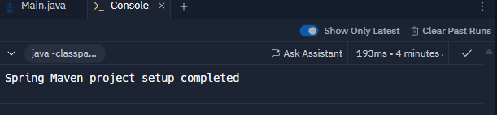

**Exercise 5: Configuring the Spring IOC Container**

**ApplicationContext.xml**

<?xml version="1.0" encoding="UTF-8"?>

<beans xmlns="http://www.springframework.org/schema/beans"

xmlns:xsi="http://www.w3.org/2001/XMLSchema-instance"

xsi:schemaLocation="

http://www.springframework.org/schema/beans

http://www.springframework.org/schema/beans/spring-beans.xsd">

<!-- Bean for BookRepository -->

<bean id="bookRepository" class="com.library.repository.BookRepository" />

<!-- Bean for BookService with DI -->

<bean id="bookService" class="com.library.service.BookService">

<property name="bookRepository" ref="bookRepository" />

</bean>

</beans>

**BookRepository.java**

package com.library.repository;

public class BookRepository {

public void save() {

System.out.println("Book saved successfully.");

}

}

**BookService.java**

package com.library.service;

import com.library.repository.BookRepository;

public class BookService {

private BookRepository bookRepository;

public void setBookRepository(BookRepository bookRepository) {

this.bookRepository = bookRepository;

}

public void addBook() {

System.out.println("Loading the book");

bookRepository.save();

}

}

**Main.java**

import com.library.service.BookService;

import org.springframework.context.ApplicationContext;

import org.springframework.context.support.ClassPathXmlApplicationContext;

public class Main {

public static void main(String[] args) {

ApplicationContext context = new ClassPathXmlApplicationContext("applicationContext.xml");

BookService bookService = (BookService) context.getBean("bookService");

// Call method to test DI

bookService.addBook();

}

}

**Output:**

